- Create a contingency table in Excel or Google Sheets showing the relationship between users' favorite food delivery app (Zomato, Swiggy, Uber Eats) and their preferred payment method (Paytm, PhonePe, Credit Card) using a sample of at least 20 responses.
ANSWERS:
Formula: ∑ Ei​(Oi​−Ei​)2 / Ei
H0: Payment method does not effect on food Delivery App
H1: Payment method does effect on food Delivery App
Significance Level: 0.05
P-value: 0.80005
0. 80005 > 0.05
Table:
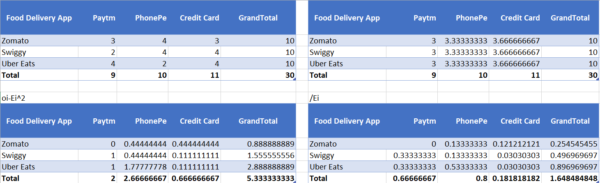
Degree of freedom:
R = 3
C = 3
(3-1) * (3-1)
2 * 2
df = 4
Critical Value
9.488
Decision: Fail to Reject H0.
Conclusion. Here our χ² critical is less then X critical value calculated so we fail to reject null hypothesis.

2.) Given the following observed counts of music streaming preference among males and females: Spotify (Males: 12, Females: 18), Gaana (Males: 8, Females: 7), YouTube Music (Males: 10, Females: 15), calculate the expected counts for each cell assuming independence.
Hint: Use the formula: (row total × column total) / grand total.
ANSWERS:
H0: music streaming platform does not effect on food Delivery App
H1: music streaming platform does effect on food Delivery App
Significance Level: 0.05
P -value: 0.65
0.65 > 0.05
Gender | Spotify | Gaana | YouTube Music | Grand Total
Male | 12.85714 | 6.428571 | 10.71429 | 30
Female | 17.14286 | 8.571429 | 14.28571 | 40
Total | 30 | 15 | 25 | 70

Degree of freedom:
R = 2
C = 3
(2-1) * (3-1)
1 * 2
Df = 2
Critical Value
5.991
Decision: Fail to Reject
Conclusion: Here our x critical is greater than x calculated so we fail to reject null hypothesis

3.) Perform a chi-square test of independence using the data from your contingency table in task 1 to determine if there is a significant association between app choice and payment method. Show your calculation steps and state your conclusion.
ANSWERS:
Formula: ∑ Ei​(Oi​−Ei​)2 / Ei
H0: Payment method does not effect on food Delivery App
H1: Payment method does effect on food Delivery App
Significance Level: 0.05
P-value: 0.80005
80005 > 0.05
Table:

Degree of freedom:
R = 3
C = 3
(3-1) * (3-1)
2 * 2
df = 4
Critical Value
9.488
Decision: Fail to Reject H0.
Conclusion. Here our χ² critical is less then X critical value calculated so we fail to reject null hypothesis.

4.) For a new Flipkart product launch, suppose you surveyed 30 users and observed the following: 18 prefer the new product, 12 do not. If the company claims that 70% of users will prefer the new product, perform a chi-square goodness of fit test to check this claim.
Hint: Calculate expected counts based on the claimed proportion.
ANSWERS:
H0: 70 % of users prefers the new products
H1: the proportion of users who prefer the new product is different from 70%.
Significance Level: 0.05
P-value: 0.23 > 0.05
Table:
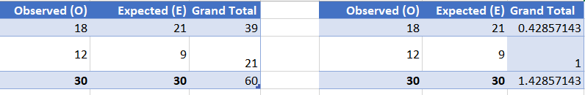
Degree of freedom:
R = 2
C = 2
(2-1) * (2-1)
Df = 1
Critical value:
3.84
Decision: we fail to reject H0
Conclusion: Here our χ² critical is greater then X critical value calculated so we fail to reject null hypothesis.

